**SQL Server Installation for RDS**

**Prerequisites:**

1. Download and extract sql server express to c:\install\sql
2. Copy the text to create a configuration file for an unattended installation, at the end of this document. Create the configuration file in c:\install\sql
3. Download sql server management studio but do not install yet. Download to c:\install\sql
4. Make sure firewall port 1433 is open
5. If you’re installing a partition other than c:\ make sure the drive is formatted and ready.

**Steps:**

1. Open command prompt , cd into c:\install\slq and run setup /configurationfile = configurationfile.ini
2. Run msiexec.exe /i “sqlmanagementstudio.msi” /quiet
3. When installation is finished go to start and then select “SQL Server xxxx Configuration Manager”

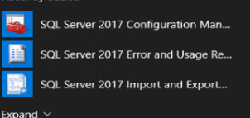

1. Go through and make sure everything that is TCPIP and Named Pipes is set to enabled. It is not enabled by default

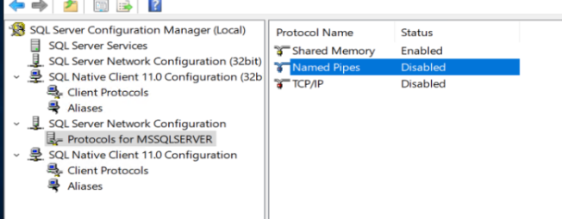

1. Reboot
2. If there is a gmsa or service account you want to run the sql server service now is the time to set that up,
3. Otherwise open Microsoft SQL Server Management Studio
4. Right click under database and select new database. Create a database for rds. In this instance it is “RDSDB”
5. Next go under security\Logins find your broker servers. Right click and select User mapping, and check the rds database.

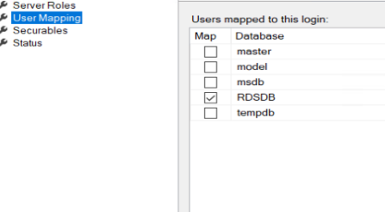

1. On the bottom window select DB_owner. Do this for both brokers

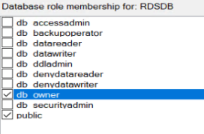

RDS Database is now setup. Below is the configurationfile.ini file that is needed for an unattended install. Fill in the blanks for the variables marked with “$”

**Configurationfile.ini:**

**#Replace $driveletter,$domain,$broker1$(make sure you have the $ at the end),$broker2$**

;SQL Server 2017 Configuration File

[OPTIONS]

; By specifying this parameter and accepting Microsoft R Open and Microsoft R Server terms, you acknowledge that you have read and understood the terms of use.

IACCEPTPYTHONLICENSETERMS="False"

; Specifies a Setup work flow, like INSTALL, UNINSTALL, or UPGRADE. This is a required parameter.

ACTION="Install"

; Detailed help for command line argument ROLE has not been defined yet.

ROLE="AllFeatures_WithDefaults"

; Specifies that SQL Server Setup should not display the privacy statement when ran from the command line.

SUPPRESSPRIVACYSTATEMENTNOTICE="False"

; By specifying this parameter and accepting Microsoft R Open and Microsoft R Server terms, you acknowledge that you have read and understood the terms of use.

IACCEPTROPENLICENSETERMS="False"

; Use the /ENU parameter to install the English version of SQL Server on your localized Windows operating system.

ENU="True"

; Setup will not display any user interface.

QUIET="False"

; Setup will display progress only, without any user interaction.

QUIETSIMPLE="False"

; Parameter that controls the user interface behavior. Valid values are Normal for the full UI,AutoAdvance for a simplied UI, and EnableUIOnServerCore for bypassing Server Core setup GUI block.

UIMODE="Normal"

; Specify whether SQL Server Setup should discover and include product updates. The valid values are True and False or 1 and 0. By default SQL Server Setup will include updates that are found.

UpdateEnabled="True"

; If this parameter is provided, then this computer will use Microsoft Update to check for updates.

USEMICROSOFTUPDATE="False"

; Specify the location where SQL Server Setup will obtain product updates. The valid values are "MU" to search Microsoft Update, a valid folder path, a relative path such as .\MyUpdates or a UNC share. By default SQL Server Setup will search Microsoft Update or a Windows Update service through the Window Server Update Services.

UpdateSource="MU"

; Specifies features to install, uninstall, or upgrade. The list of top-level features include SQL, AS, IS, MDS, and Tools. The SQL feature will install the Database Engine, Replication, Full-Text, and Data Quality Services (DQS) server. The Tools feature will install shared components.

FEATURES=SQLENGINE,CONN,BC,SDK

; Displays the command line parameters usage

HELP="False"

; Specifies that the detailed Setup log should be piped to the console.

INDICATEPROGRESS="False"

; Specifies that Setup should install into WOW64. This command line argument is not supported on an IA64 or a 32-bit system.

X86="False"

; Specify a default or named instance. MSSQLSERVER is the default instance for non-Express editions and SQLExpress for Express editions. This parameter is required when installing the SQL Server Database Engine (SQL), or Analysis Services (AS).

INSTANCENAME="MSSQLSERVER"

; Specify the root installation directory for shared components. This directory remains unchanged after shared components are already installed.

INSTALLSHAREDDIR="$driveletter:\Program Files\Microsoft SQL Server"

; Specify the root installation directory for the WOW64 shared components. This directory remains unchanged after WOW64 shared components are already installed.

INSTALLSHAREDWOWDIR="$driveletter:\Program Files (x86)\Microsoft SQL Server"

; Specify the Instance ID for the SQL Server features you have specified. SQL Server directory structure, registry structure, and service names will incorporate the instance ID of the SQL Server instance.

INSTANCEID="MSSQLSERVER"

; TelemetryUserNameConfigDescription

SQLTELSVCACCT="NT Service\SQLTELEMETRY"

; TelemetryStartupConfigDescription

SQLTELSVCSTARTUPTYPE="Automatic"

; Specify the installation directory.

INSTANCEDIR="$driveletter:\Program Files\Microsoft SQL Server"

; Agent account name

AGTSVCACCOUNT="NT AUTHORITY\NETWORK SERVICE"

; Auto-start service after installation.

AGTSVCSTARTUPTYPE="Disabled"

; CM brick TCP communication port

COMMFABRICPORT="0"

; How matrix will use private networks

COMMFABRICNETWORKLEVEL="0"

; How inter brick communication will be protected

COMMFABRICENCRYPTION="0"

; TCP port used by the CM brick

MATRIXCMBRICKCOMMPORT="0"

; Startup type for the SQL Server service.

SQLSVCSTARTUPTYPE="Automatic"

; Level to enable FILESTREAM feature at (0, 1, 2 or 3).

FILESTREAMLEVEL="0"

; Set to "1" to enable RANU for SQL Server Express.

ENABLERANU="True"

; Specifies a Windows collation or an SQL collation to use for the Database Engine.

SQLCOLLATION="SQL_Latin1_General_CP1_CI_AS"

; Account for SQL Server service: Domain\User or system account.

SQLSVCACCOUNT="NT Service\MSSQLSERVER"

; Set to "True" to enable instant file initialization for SQL Server service. If enabled, Setup will grant Perform Volume Maintenance Task privilege to the Database Engine Service SID. This may lead to information disclosure as it could allow deleted content to be accessed by an unauthorized principal.

SQLSVCINSTANTFILEINIT="False"

; Windows account(s) to provision as SQL Server system administrators.

SQLSYSADMINACCOUNTS="$domain\$username" "$domain\$broker1$" "$domain\$broker2$" "$domain\Domain Admins"

; The number of Database Engine TempDB files.

SQLTEMPDBFILECOUNT="1"

; Specifies the initial size of a Database Engine TempDB data file in MB.

SQLTEMPDBFILESIZE="8"

; Specifies the automatic growth increment of each Database Engine TempDB data file in MB.

SQLTEMPDBFILEGROWTH="64"

; Specifies the initial size of the Database Engine TempDB log file in MB.

SQLTEMPDBLOGFILESIZE="8"

; Specifies the automatic growth increment of the Database Engine TempDB log file in MB.

SQLTEMPDBLOGFILEGROWTH="64"

; Provision current user as a Database Engine system administrator for %SQL_PRODUCT_SHORT_NAME% Express.

ADDCURRENTUSERASSQLADMIN="True"

; Specify 0 to disable or 1 to enable the TCP/IP protocol.

TCPENABLED="0"

; Specify 0 to disable or 1 to enable the Named Pipes protocol.

NPENABLED="0"

; Startup type for Browser Service.

BROWSERSVCSTARTUPTYPE="Disabled"